**The Shrew Caravan:**

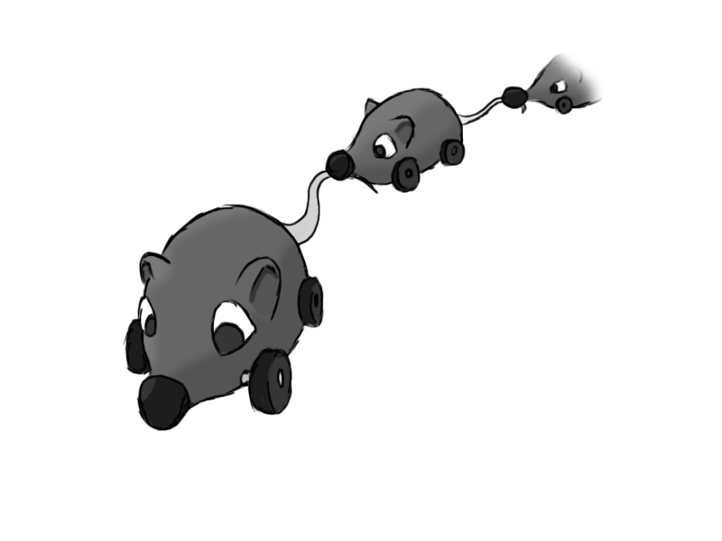

Figure 1 - Enemy: Shrew Caravan

**Brief Synopsis**

The shrew caravan consists of a mother shrew, and several smaller baby shrews. Each baby shrew has the tail of the shrew in front in its mouth, creating a chain. Based off old wheeled toys that were dragged around, these will be weak enemies, but the large size and unpredictability when hit will pose a challenge. When one is hit, the baby shrews behind it detach from each other, and race off in a straight line from where they are facing, bouncing off walls. Attacking them from the last baby to the mother will prevent the area being swarmed, whereas the scythe can cut down the numbers quickly.

**Variants.**

Variants of the mother shrew would make it so that she targets the player, pathfinding towards him while keeping her angular velocity within limits. This is triggered by range, and the mother will return to the closest point on her path. A further variant can have it not deactivate when out of range.

Variants for the baby shrews would change their collision behaviour. One variant has it charge in a random direction after collision, with the other heading towards you if it can do so, reflecting as normal otherwise.

**AI**

The mother will follow a pre-set path around the area, probably via spline paths, and the baby shrews will follow, attached to each other by the tail. When a shrew dies, the one behind charges forwards, and sets a trigger to the one behind to do the same, until the last shrew is reached. Hence each shrew needs to know which shrew is behind it. They will charge forwards in the direction they are facing, reflecting off walls.

**Animations**

The shrew will not need much in the way of animations, as it damages by running over.

**Move:**

* Wheels on the shrew rotate forwards, propelling it along, with the occasional wobble to simulate loss of balance.

**Rotate:**

* Baby shrew will rotate back and forth before picking an angle at which to move at. The wheels will rotate in opposite directions.

**Death:**

* The shrew will fall on its side before exploding.

**Average Size**

